## **Invitation letter**

Dear………………………………………..……………. Date…………………………………………….

Thank you for expressing an interest in becoming a volunteer with the Scouts. This letter explains the process of applying for an Access Northern Ireland disclosure check (criminal records check) which is one part of The Scouts’ vetting process. Once you have completed your application, we will need to meet so I can view your identity documents and finalise your application on scouts.org.uk.

Could we please arrange to meet:

**Date: Time: Venue:**

The completion of the AccessNI check is an important part of keeping young people in Scouting safe, we recognise that if you have a criminal record this is not an automatic bar to obtaining a position.

Your personal data will be stored on your membership record (scouts.org.uk) to support your application process, as well as your current and potential future involvement in Scouting. It is also kept for monitoring purposes. Some information is considered special category data under the General Data Protection Regulation and the Data Protection Act 2018, and as such will be managed as required under the regulation. Further information can be found at [www.scouts.org.uk/dppolicy](http://www.scouts.org.uk/dppolicy)

**To enable your AccessNI online application to be completed, you will need to have a NI Direct online account (NIDA LOA2). You may have a NI Direct account already if you’ve, for example, recently renewed your driving licence or for covid certification in which case you should use that account you already have. You can tell if it’s updated to a LOA2 account by how you log on- you should have multifactor authentication (secure code) log on. Guidance can be found at** [**Guide to creating a NIDA LOA2 account for AccessNI applications | nidirect**](https://www.nidirect.gov.uk/publications/guide-creating-nida-loa2-account-accessni-applications)

**Before our meeting, please ensure that you**

1. Already have a NIDA LOA2 account (or have created one); and
2. Have already created an Access Northern Ireland (Access NI) application
3. Have uploaded 2 identity documents from the List of Acceptable Documents below to your Access Northern Ireland application. To avoid delays, Access Northern Ireland recommends that you upload
4. your birth certificate issued at the time of birth (or another suitable document that confirms your name at birth and date of birth) AND
5. a second document that confirms your name and has a photographic image of you.

**See pages 4-7 below for instructions on how to create your Access Northern Ireland application**

**After you have created your Access NI application, please bring with you to our meeting**

1. The same 2 documents from the List of Acceptable Documents that you have already uploaded to your application as evidence of your identity. These should be original documents, not photcopies, scans or print outs.
2. The case reference number from your completed Access NI application and confirmation email.
3. Your NIDA LOA2 login details
4. National Insurance number (if you have one).
5. Driving licence (if you hold one).
6. Passport (if you hold one).
7. Your address(es) for the last five years (along with corresponding dates)
8. Details of referees if applicable (please complete the section on page 3). Please note references are not required for Helpers.

**LIST OF ACCEPTABLE DOCUMENTS**

|  |  |
| --- | --- |
| Doc Ref |  |
| 1 | **Original Birth certificate (issued within 12 months of birth)** |
|  | UK, Isle of Man and Channel Islands - including those issued by UK authorities overseas, eg Embassies, High Commissions and HM Forces |
| 3 | **Certified copy of birth certificate (issued more than 12 months after time of birth)** |
|  | UK, Isle of Man, Channel Islands or Ireland |
| 4 | **Long form Irish birth certificate (issued at time of registration of birth)** |
|  | Ireland |
| 5 | **Adoption Certificate** |
|  | UK, Channel Islands or Ireland |
| 6 | **Passport** |
|  | Any current and valid passport |
| 7 | **Irish Passport Card** |
|  | Cannot be used with an Irish passport, Current and Valid |
| 8 | **Current driving licence photocard** |
|  | Full or provision - UK, Isle of Man, Channel Islands or Ireland |
| 9 | **Current driving licence photocard (full or provisional)** |
|  | All countries outside the UK (excluding Isle of Man and Channel Islands) |
| 10 | **Current driving licence (full or provisional) - paper version (if issued before March 2000)** |
|  | UK, Isle of Man, Channel Islands and Ireland |
| 11 | **e-Visa** |
|  | Upload weblink and share code. |
| 12 | **Immigration document, visa or work permit** |
|  | Issued by a country outside the UK. Valid only for roles whereby the Applicant is living and working outside of the UK. Visa/permit must relate to the country in which the role is based, Current and Valid |
| 13 | **Electoral ID card** |
|  | Northern Ireland only |
| 14 | **Marriage / Civil Partnership certificate** |
|  | UK, Channel Islands or Ireland |
| 15 | **HM Forces ID card** |
|  | UK |
| 16 | **Firearms licence** |
|  | UK, Channel Islands and Isle of Man, Current and Valid |
| 17 | **Mortgage Statement** |
|  | UK or Ireland, dated within 12 months |
| 18 | **Financial statement, for example ISA, pension or endowment** |
|  | UK or Ireland, dated within 12 months |
| 19 | **P45 or P60 statement** |
|  | UK or Channel Islands, dated within 12 months |
| 20 | **Land and Property Services rates demand** |
|  | Northern Ireland only, dated within 12 months |
| 21 | **Council tax statement** |
|  | UK or Channel Islands, dated within 12 months |
| 22 | **Credit card statement** |
|  | UK or Ireland, dated within 3 months |
| 23 | **Bank or Building Society statement** |
|  | UK, Channel Islands or Ireland, dated within 3 months |
| 24 | **Utility bill (not mobile phone)** |
|  | UK or Ireland, dated within 3 months |
| 25 | **Benefit statement, for example Child Benefit, Pension etc** |
|  | UK, dated within 3 months |
| 26 | **Official Government/Council Document** |
|  | Central or local government, government agency, or local council document giving entitlement, for example from the Department for Work and Pensions, the Employment Service, HMRC, UK and Channel Islands, dated within 3 months |
| 27 | **EEA National ID card** |
|  | Current and Valid |
| 28 | **SmartPass issued by Translink** |
|  | Northern Ireland |
| 29 | **yLink card issued by Translink** |
|  | Northern Ireland |
| 30 | **Cards carrying the PASS accreditation logo** |
|  | UK, Isle of Man and Channel Islands, Current and Valid |
| 31 | **Letter from head teacher or further education college principal** |
|  | UK - for 16 to 19 year olds in full time education - only used in exceptional circumstances if other documents cannot be provided |
| 32 | **Letter of sponsorship from future employment provider or voluntary organisation** |
|  | Non UK only - Valid only for Applicants residing outside UK and Ireland at time of application |
| 33 | **Exceptional circumstances – Document agreed with AccessNI** |
|  | Cannot be used unless advised by AccessNI |
|  |  |

**References (References are not required for Helpers)**

You will need to add to scouts.org.uk the details of 3 people who can act as referees for you. They should be known to you and who can be contacted by email. The referees should preferably have knowledge of your work or contact with young people and should be able to comment on your character and relationships with others. At least one referee should have known you for at least five years and one of the referees must not be from Scouting. Referees must not be relatives. Examples of referees include your employer, college tutor, etc. The referees’ personal data will only be used for the purposes of providing a reference

|  |  |
| --- | --- |
|  | I can confirm that I have been given permission to provide the referees’ personal data and I have checked their details with them |

|  |  |
| --- | --- |
| **Referee No. 1** Name | Relationship |
| Email | Phone Number |
| Address | Postcode |

|  |  |
| --- | --- |
| **Referee No. 2** Name | Relationship |
| Email | Phone Number |
| Address | Postcode |

|  |  |
| --- | --- |
| **Referee No. 3** Name | Relationship |
| Email | Phone Number |
| Address | Postcode |

**How To start an application for an Enhanced Disclosure/Criminal Records check**

Access NI Code of Practice can be accessed via the Access NI website - <https://www.nidirect.gov.uk/publications/accessni-code-practice>

To find out how personal information you send to AccessNI will be handled when using this service, go to:

[AccessNI privacy notice](https://www.justice-ni.gov.uk/publications/ani-privacy)

1. Go through the nidirect website: <https://www.nidirect.gov.uk/campaigns/accessni-criminal-record-checks>
2. Select the option ‘Apply for an AccessNI check’ and then select the option to ‘Apply online for an enhanced check through a REGISTERED body’.
3. Select the green button and log-in or create a new nidirect account [NIDA].

1. If you don’t aready have a NIDA you will need to create one. Select “Create Account” button and follow the instructions. Guidance for creating a NIDA LOA2 account for AccessNI applications is available to assist with the process – [Guide to creating a NIDA LOA2 account for AccessNI applications | nidirect](https://www.nidirect.gov.uk/publications/guide-creating-nida-loa2-account-accessni-applications). Applications must be completed using your own nidirect account

The create an account / log in page looks like this:

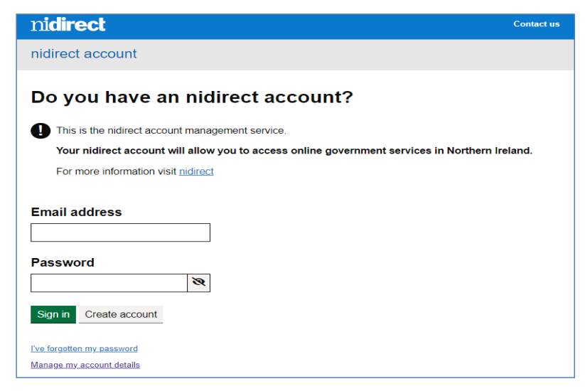

Click on ‘Create account’. Take a note of your email address and password as you may need this later.

1. I will have provided you with a 6-digit PIN number. Enter The Scouts’ PIN number and click ‘Next’.

1. The system will display the name of The Scouts’ HQ Signatory, along with the name of the organisation (The Scouts). If it does not say ‘The Scouts’ or ‘The Scout Association’ it may be that you have entered in the wrong 6-digit number. In which case, click ‘Back’ and re-enter the number.

1. The system will take you to the Application and prompt you to complete your details onto screen.

There are a number of screens to work through, providing details as required. Once you have completed each screen you should click the ‘Next’ button to continue to the next screen.

You will be required to provide a full 5-year address history, along with dates you lived at these addresses. Overlapping dates are acceptable, but there can be no gaps in these dates.

1. The outcome certificate will be provided to you digitally in your NIDA account where you can view and share your digital certificate unless you select the button for a paper certificate. If you request a paper certificate, you will not receive a digital copy.

If there is adverse information on your certificate, you will receive a paper certificate by post.



1. The final page in this part of the process is the Confirmation page

Please print or screenshot the screen and **note the case reference number** in case you need to ask questions about your application. This number will also be displayed on your disclosure certificate, which will be issued to you once AccessNI has completed its work.

You will also have received an email to confirm that this part of the disclosure process has been completed and your case has been forwarded to the appropriate body (The Scouts) for approval.

**We can then meet to review your identity documents**

You can track the progress of your application either by clicking on the highlighted link on the page above or on the same link at the bottom of the e-mail that is sent at this stage in the process.

If you require any further assistance with completion of the e-application you should either contact The Scouts’ HQ Disclosures staff via [Disclosures@scouts.org.uk](mailto:Disclosures@scouts.org.uk) or contact AccessNI on 0300 200 7888

Thank you.

Name:…………………………………………………………Appointment: ………………………………………………………………………………………..