How to Generate a Compliance Assistant Report

This shows an example of how to generate a report on a MacBook Pro. It will be similar for other roles and other operating systems.

After downloading the Compliance Assistant, you will see the “Green Screen” until the program has been downloaded and Macros enabled.
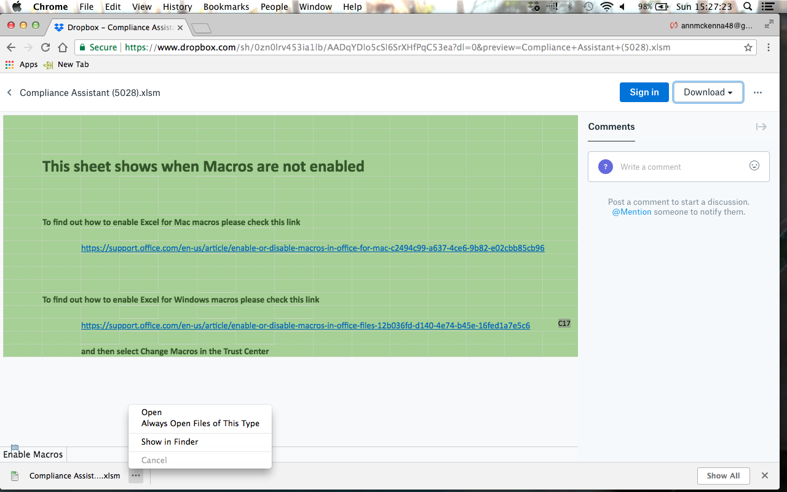

Once the program has been downloaded and you try to open it you may see a message like this.
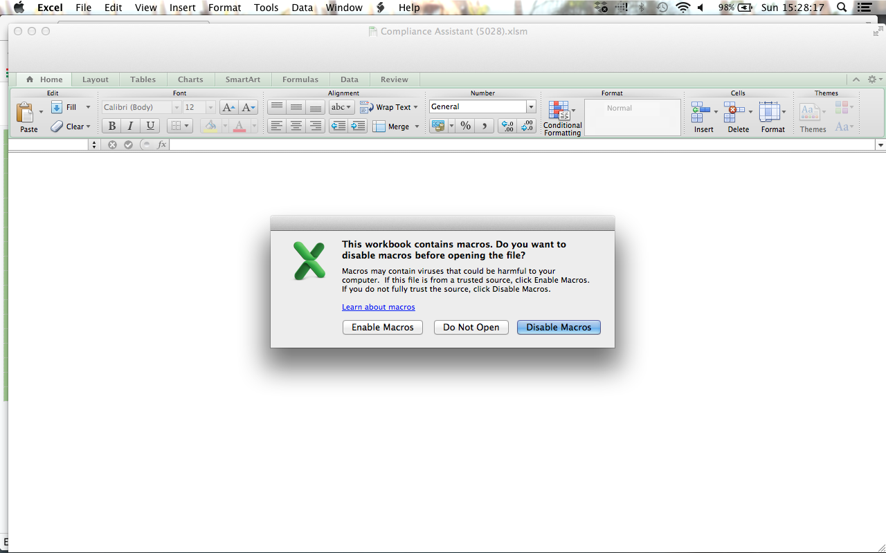

Once Macros have been enabled the screen will change to orange.
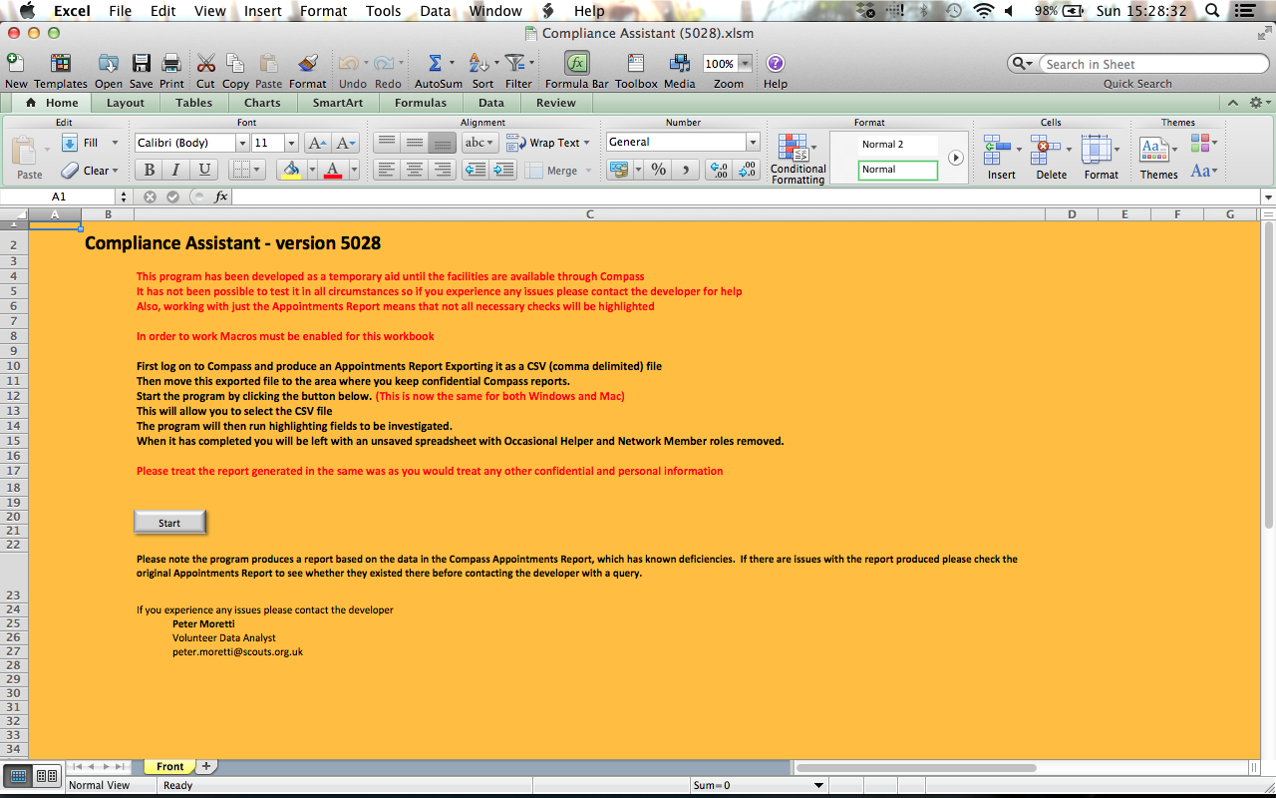

Click the Start button and you will be asked to select a file. You may either enter the name including folder or you can use the Browse button to select the file. Click the OK button once you have selected the correct file. The program will then run.
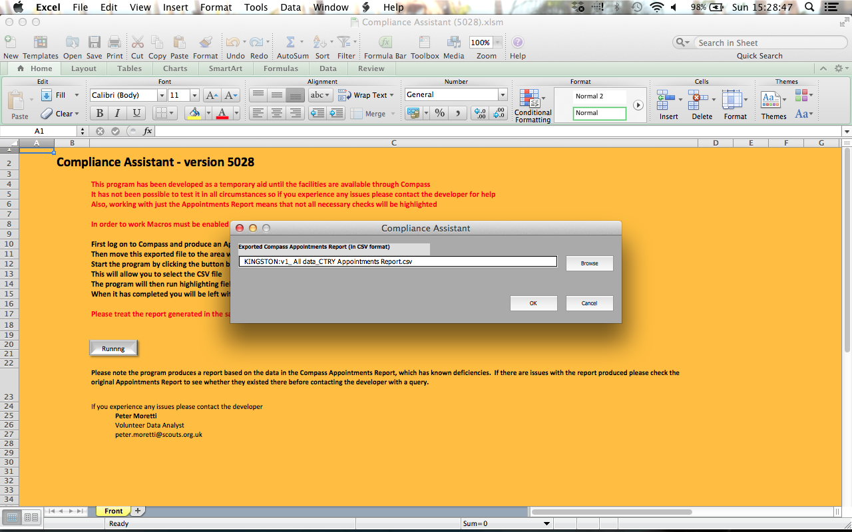

The report will then be generated and you will be left with an unsaved Compliance Assistant report. Click the OK button and save the report to an area for confidential information.
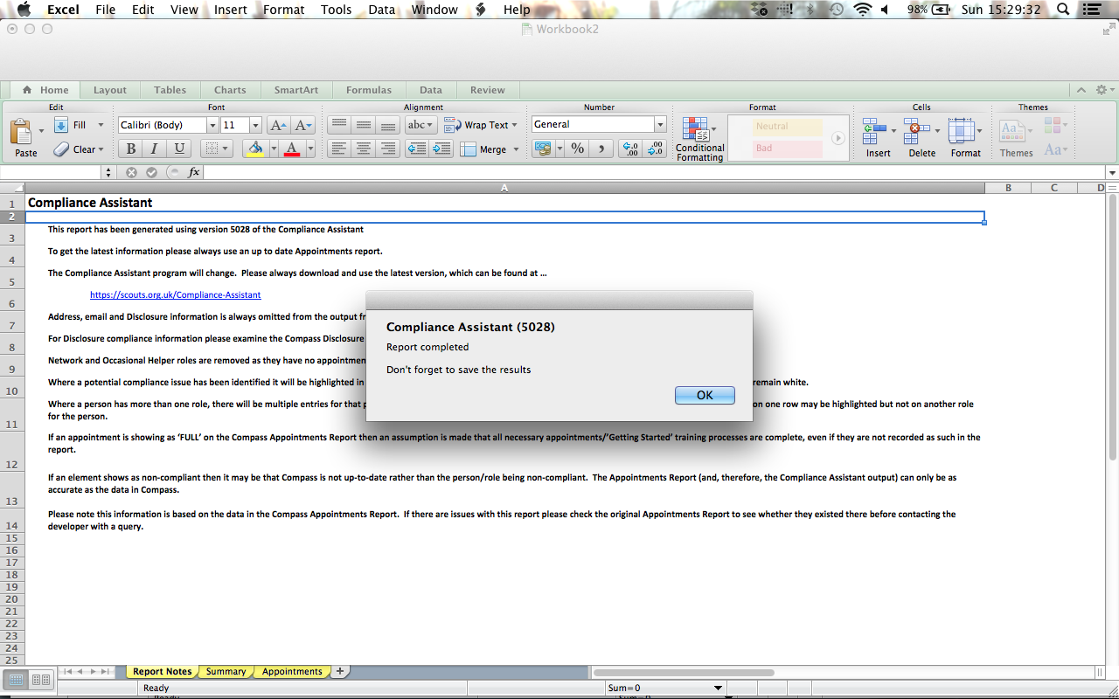

How to Export a Compass Report to a CSV File

This shows an example of how to export a report on a Microsoft Windows 7 system. It will be similar for other roles, other versions of Windows and other operating systems.

Firstly log in to Compass and select Messaging/Report the Reports
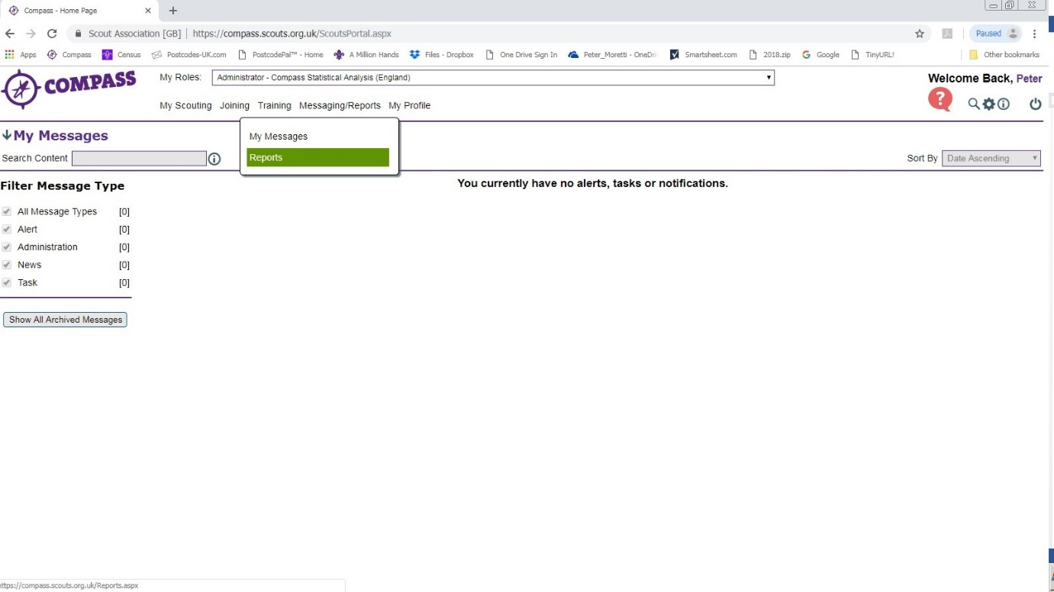

Then select Appointments Report
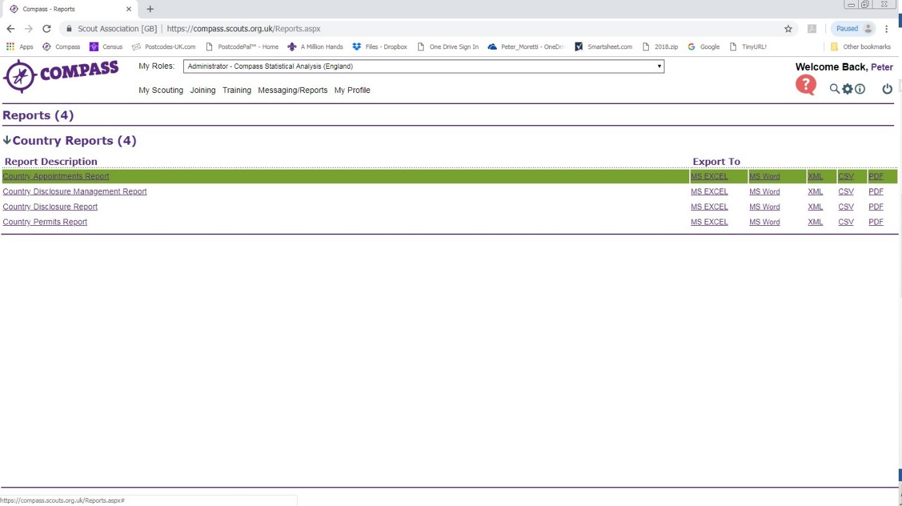

Once the report has generated the initial version select the information required, and then click View Report.
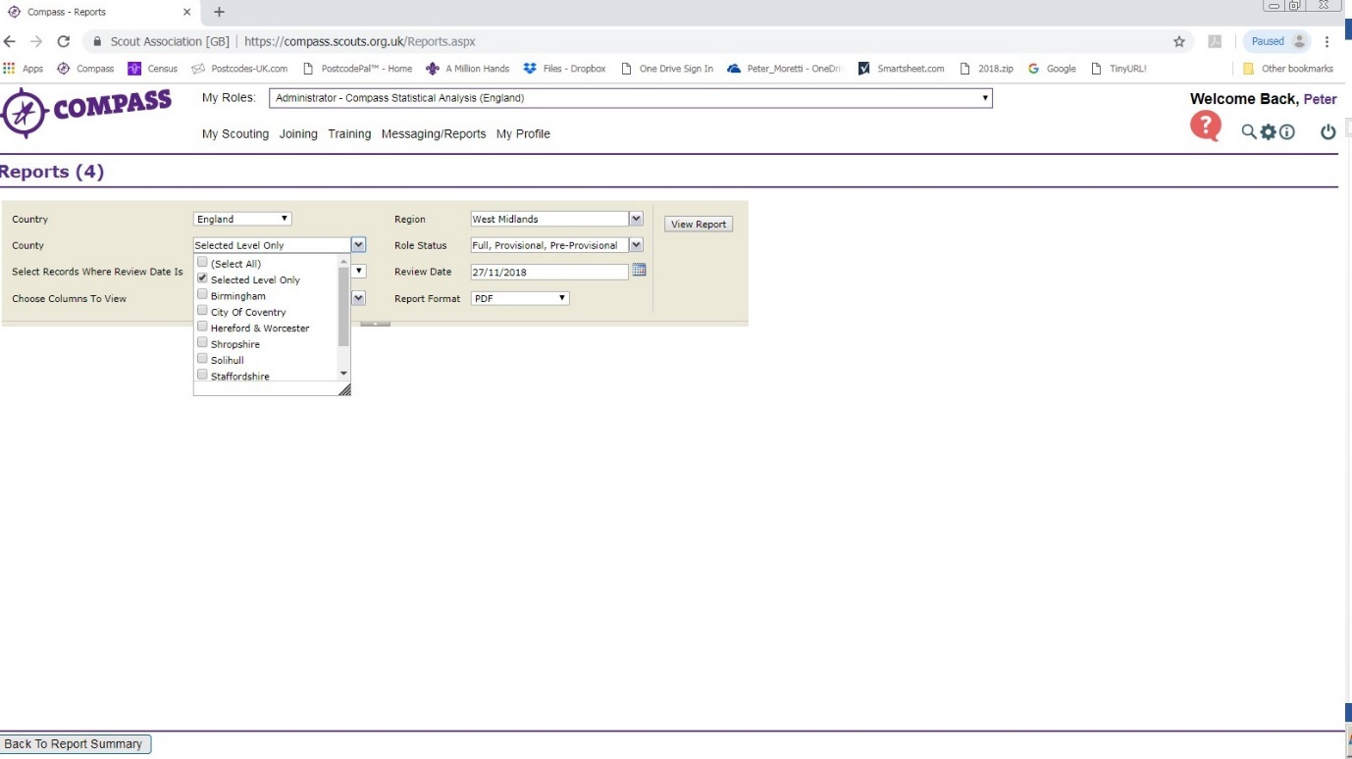

Once the report has been generated select CSV (comma separated) on the Export dropdown.
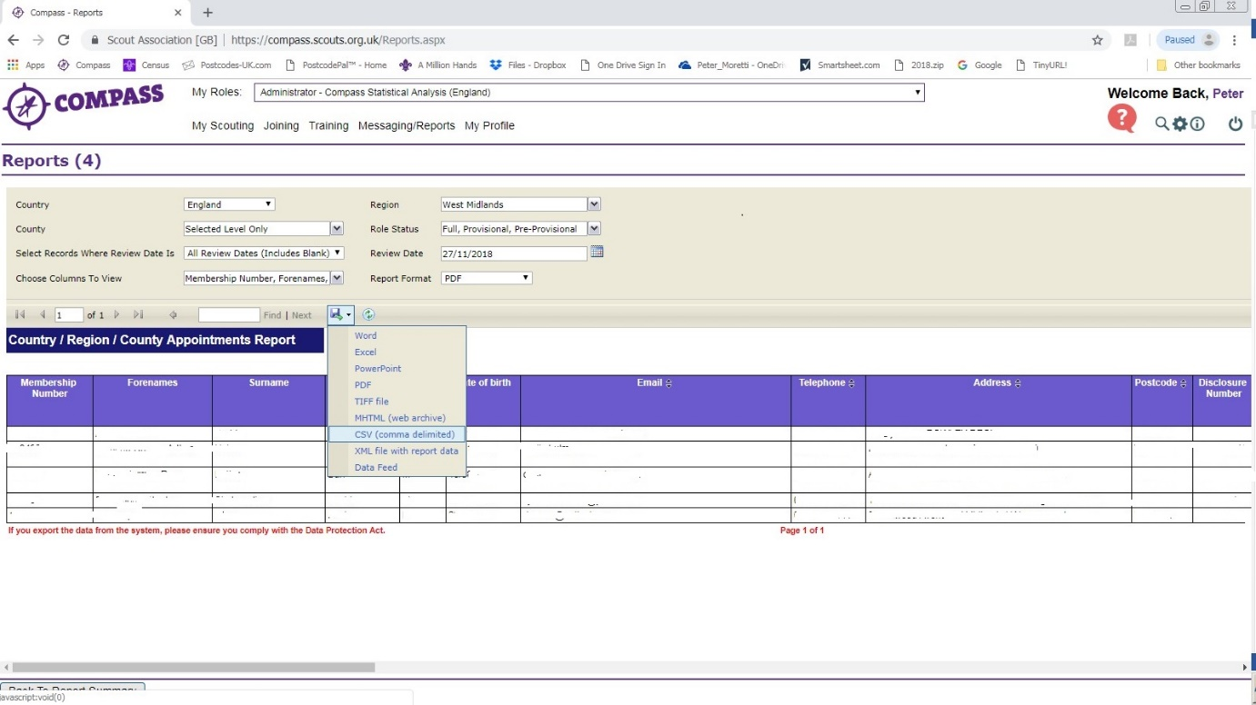

When the report has been generated select Show in Folder and move the file generated to an appropriate place for confidential information.

Version history notes

Compliant Assistant v6071

A number of changes have been made since the previously issued version.
If you have any issues please contact data-insights@scouts.org.uk

Changes v6071
-------------
Updated to January 2021 POR
Section added to the Appointments sheet.
Due Soon highlighting before date as alternative to period in months
Minor other changes and bug fixes.

Changes v6070
-------------
This has major internal changes to support the September 2020 POR and the transition rules.
Trustee Introduction is now supported
Mandatory Ongoing Learning Renewal By columns added to Appointments sheet
Minor bug fixes

Changes v6067
-------------
The primary aim of this version is to support the new information available in the September 2020 version of the Compass Appointments Report.
This new information includes Essential Information for Execs, Tools for Role Managers and Supporters, GDPR and Trustee Introduction.
This program still uses the training requirements from the January 2020 version of Table 2 from the Appointments Process of POR.
A further version will be issued as soon as possible to include the September 2020 training requirements and transition process.

Changes v6066
-------------
Now able to produce multiple sub-reports from District, County, Region, Area files, etc.
Able to save the report(s) generated automatically.
Improved logic to correct bug in Subtotals. This also affected Summary logic
Simple help from from the front to a separate sheet.
A number of minor bug fixes.

Changes v6065
-------------
The internal Role Requirements information has been improved to be more consistent with the January 2020 POR update.
There is a new Subtotal sheet that gives the figures if filters are applied on the Appointments sheet
The end message now gives the option to delete the input file.
Internal changes to support the changes in this version and prepare for future versions
A number of bug fixes.

Changes v6061
-------------
A minor change to the logic that determines whether Safety and Safeguarding are Due Soon when Module 1 hasn't been completed.

Changes v6060
-------------
The most noticeable change has been the revision of the Summary sheet including moving some of the basic information
to the Notes sheet. It is hoped that the new Summary sheet will help to make the report more useful.
The Summary page totals some requirements by individual rather than roles where the training is applicable across all
roles e.g. First Aid, Safety, etc. This has not yet been applied to Appointments sheet, so a requirement may be highlighted
against one role even where this has already been completed against another.
Significant other changes have been made to the highlighting logic to improve its accuracy and supportability.

Changes v5048
-------------
Email addrresses have been added to the generated report
The initial form that requests the inout file now also enables removal of a few columns from the report.
Significant internal changes have been made to try to ensure the program operates correctly on a Mac.

Changes v5043
-------------
The internal table that checks the requirements for every role have been revised in line with January 2019 POR.
Previous version used a pre-release set of requirements
A correction has been made to the logic affecting whether references are required. In the past some were missed.

Changes v5042
-------------
This version has been tested to work with Excel on Windows and Excel Mac 2011 and 2016.

