## **Invitation letter**

Dear………………………………………..……………. Date…………………………………………….

Thank you for expressing an interest in becoming a volunteer with the Scouts. To start your application process we need to arrange to meet so we can enter your details onto the Scouts’ membership database and complete your AccessNI online application.

The completion of the AccessNI check is an important part of keeping young people in Scouting safe, we recognise that if you have a criminal record this is not an automatic bar to obtaining a position.

Your personal data will be stored on your membership record (scouts.org.uk) to support your application process, as well as your current and potential future involvement in Scouting. It is also kept for monitoring purposes. Some information is considered special category data under the General Data Protection Regulation and the Data Protection Act 2018, and as such will be managed as required under the regulation. Further information can be found at [www.scouts.org.uk/dppolicy](http://www.scouts.org.uk/dppolicy)

Could we please arrange to meet:

**Date: Time: Venue:**

To enable your AccessNI online application to be completed during our meeting, you will need to create an AccessNI NI Direct online account beforehand. See pages 3 & 4 for step-by-step instructions.

If you don’t have an email address an email account could be created in your name using a free online account such as gmail or hotmail.

Please bring the following to the meeting:

1. Your AccessNI NI Direct login details (email address and password).

2. Three documents in your name; **one from Group 1 and two from Groups 1 or 2a or 2b**. At least one document must show your current address. If this is not possible, then **four documents from Group 2a** and **2b** should be produced. See list of suitable documents below.

3. National Insurance number.

4. Driving licence number (if you hold one).

5. Passport number (if you hold one).

6. Your address(es) for the last five years.

7. Details of referees if applicable (please complete the section on page 2). Please note references are not required for Helpers.

**Group 1 identity documents** You must select one from the list below:

|  |
| --- |
| Current passport (any nationality) |
| Biometric Residence Permit (UK) |
| Current, valid driving licence photocard (full or provisional) (UK, Isle of Man, Channel Islands or Ireland) |
| Birth certificate issued within 12 months of birth (UK, Isle of Man or Channel Islands- including those issued by UK authorities overseas, for example embassies, High Commissions and HM Forces) |
| Long form Irish birth certificate issued at time of registration of birth (Ireland) |
| Adoption certificate (UK, Channel Islands or Ireland) |

**Group 2a identity documents** You must select two from the list below:

|  |
| --- |
| Birth certificate issued after time of birth (UK, Isle of Man, Channel Islands or Ireland) |
| Marriage/civil partnership certificate (UK, Channel Islands or Ireland) |
| HM Forces ID card (UK) |
| Firearms licence (UK, Channel Islands, Isle of Man) |
| Current, valid driving licence photocard -full or provisional (all countries outside the UK excluding Isle of Man and Channel Islands) |
| Current, valid driving licence -full or provisional -paper version if issued before 1998 (UK, Isle of Man, Channel Islands or Ireland) |
| Electoral ID card (NI only) |
| Immigration document, visa or work permit Issued by a country outside the UK. Valid only for roles whereby the applicant is living and working outside of the UK. Visa/permit must relate to the country in which the role is based. |

**Group 2b documents**

|  |  |
| --- | --- |
| Mortgage statement (UK or Ireland) | Issued within the last 12 months |
| Financial statement, for example ISA, pension or endowment (UK or Ireland) | Issued within the last 12 months |
| P45 or P60 statement (UK, Channel Islands) | Issued within the last 12 months |
| Land & Property Services rates demand (Northern Ireland only) | Issued within the last 12 months |
| Council tax statement (UK and Channel Islands) | Issued within the last 12 months |
| Credit card statement (UK or Ireland) | Issued within the last 3 months |
| Bank or building society statement (UK, Channel Islands or Ireland) | Issued within the last 3 months |
| Bank or building society statement (Countries outside the UK) – the branch must be in the country where you live and work | Issued within the last 3 months |
| Bank or building society account opening confirmation letter (UK) | Issued within the last 3 months |
| Utility bill but not a mobile telephone bill (UK or Ireland) | Issued within the last 3 months |
| Benefit statement such as Child Benefit, pensions (UK) | Issued within the last 3 months |
| Central or local government, government agency, or local council document giving entitlement, for example from the Department for Work and Pensions, The Employment Service, HMRC (UK, Channel Islands) | Issued within the last 3 months |
| EEA National ID card | Must be valid when you apply |
| 60+ or Senior (65+) SmartPass issued by Translink (NI) | Must be valid when you apply |
| yLink card issued by Translink (NI) | Must be valid when you apply |
| Cards carrying the PASS accreditation logo (UK, Isle of Man, Channel Islands) | Must still be valid when you apply |
| Letter from head teacher or further education college principal (UK - for 16 to 19 year olds in full time education - only used in exceptional circumstances if other documents cannot be provided) | Must still be valid when you apply |
| Letter of sponsorship from future employment provider or voluntary organisation (Non UK only - valid only for applicants residing outside UK and Ireland at time of application) | Must still be valid when you apply |
| Irish Passport Card (cannot be used with an Irish passport) | Must still be valid when you apply |

**References (References are not required for Helpers)**

Please add details of two people to act as referees who are known to you and who can be contacted by email. The referees should preferably have knowledge of your work or contact with young people and should be able to comment on your character and relationships with others. At least one referee should have known you for at least five years and one of the referees must not be from Scouting. Referees must not be relatives. Examples of referees include your employer, college tutor, etc. The referees’ personal data will only be used for the purposes of providing a reference.

|  |  |
| --- | --- |
|  | I can confirm that I have been given permission to provide the referees’ personal data. |

|  |  |
| --- | --- |
| **Referee No. 1** Name | Relationship |
| Email | Phone Number |
| Address | Postcode |
| **Referee No. 2** Name | Relationship |
| Email | Phone Number |
| Address | Postcode |

Access NI Code of Practice can be accessed via the Access NI website - <https://www.nidirect.gov.uk/publications/accessni-code-practice>

To find out how personal information you send to AccessNI will be handled when using this service, go to:

[AccessNI privacy notice](https://www.justice-ni.gov.uk/publications/ani-privacy)

To create an NI Direct AccessNI online account, open this web address:

<https://accessni.nidirect.gov.uk/account/login>

Click on the Green Create an account button.

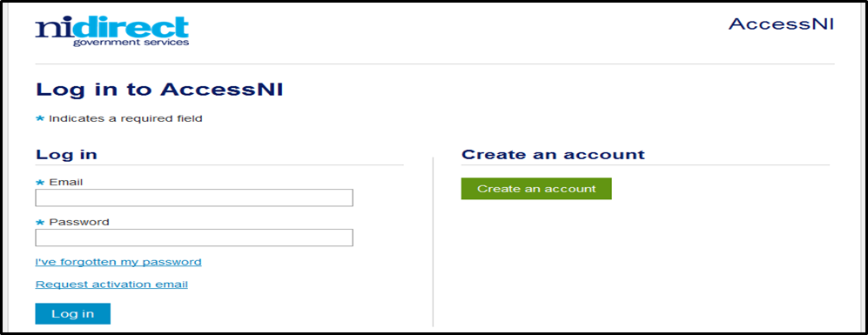

Complete the details on this form to create an account.

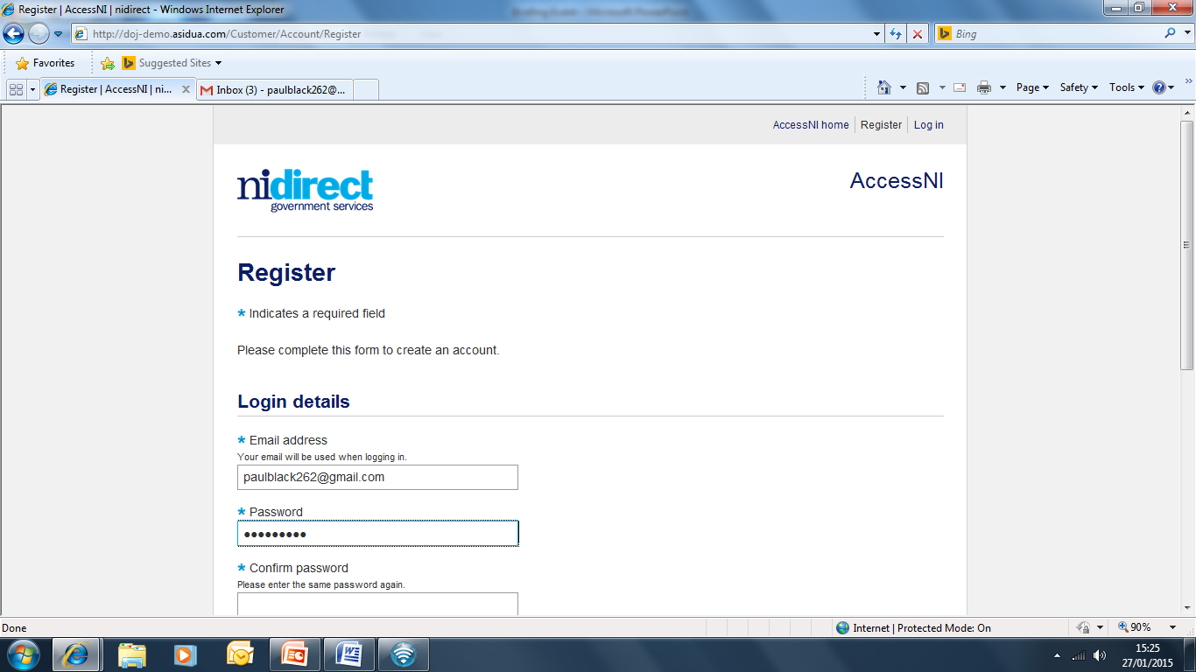

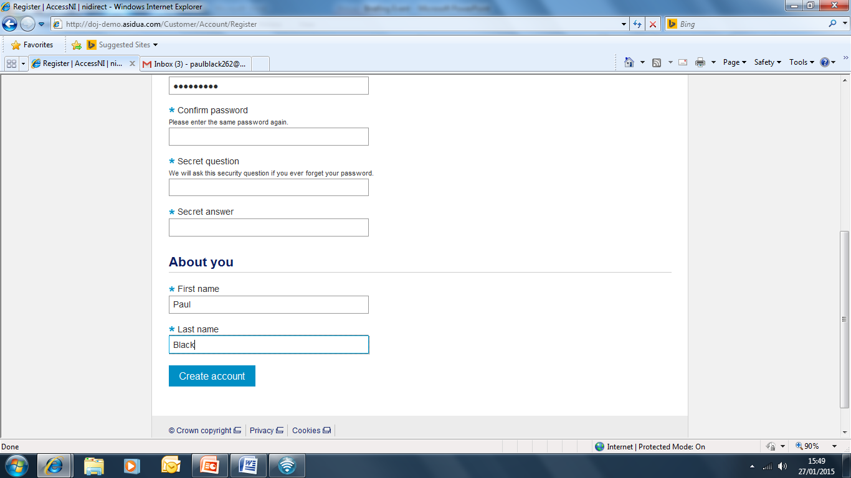

Click on Create account

Take a note of your email address and password as you will need this for completing your online application during our meeting.

This screen will then appear

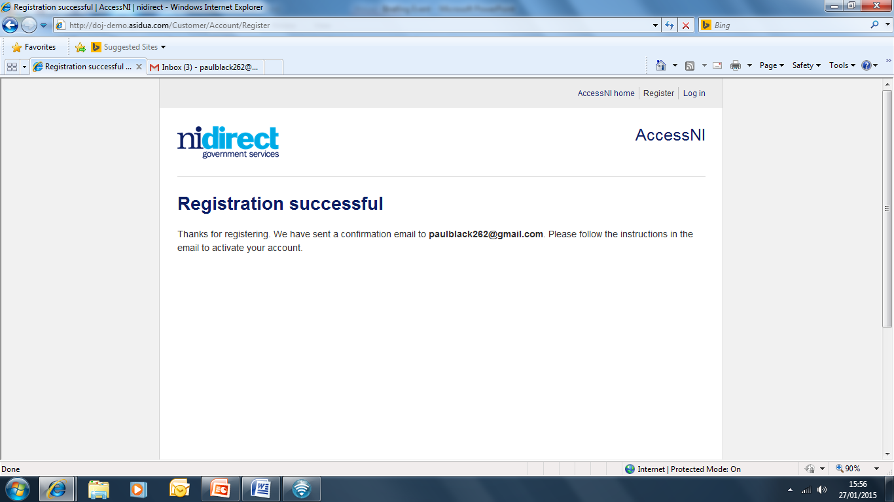

You need to log into your own email inbox where you will find a new email from AccessNI the content of which is as follows:

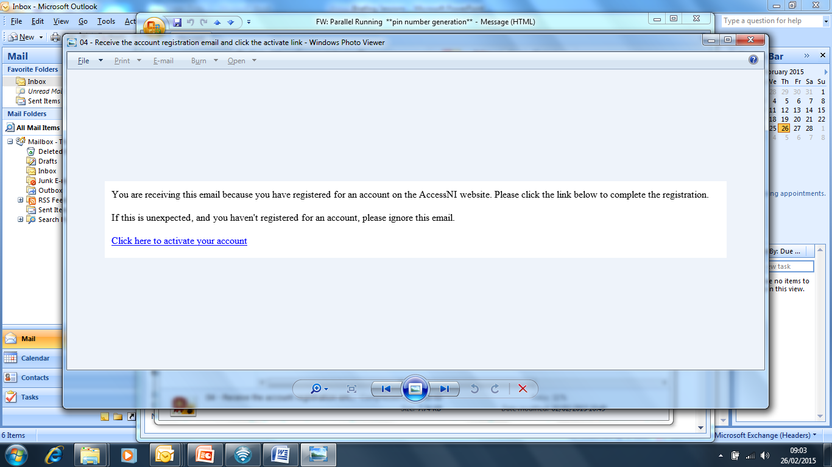

Click here to activate your account.

The remainder of your AccessNI online application will take place during our meeting.

When all 3 ID documents are checked, all of your names from all the documents must be included in the application.

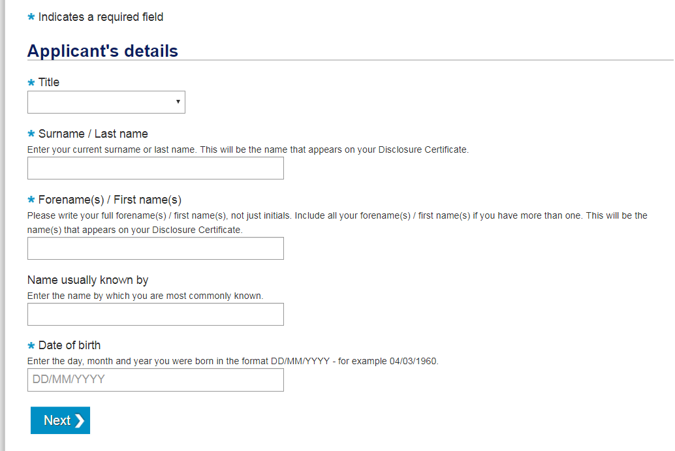

Thank you.

Name:……………………………………………………………….. Appointment: ………………………………………………………………………………………..