## **Invitation letter**

Dear……………………………………………. Date…………………………………………….

Thank you for expressing an interest in becoming a volunteer with the Scouts. To start your application process we need to arrange to meet to enter your details onto the Scouts database (Compass) and complete your AccessNI online application.

The completion of the AccessNI check is an important part of keeping young people in Scouting safe, we recognise that if you have a criminal record this is not an automatic bar to obtaining a position.

Your personal data will be stored on Compass to support your application process, as well as your current and potential future involvement in Scouting. It is also kept for monitoring purposes. Some information is considered special category data under the General Data Protection Regulation and the Data Protection Act 2018, and as such will be managed as required under the regulation. Further information can be found in Appendix A (see below) and also at [www.scouts.org.uk/dppolicy](http://www.scouts.org.uk/dppolicy)

Could we please arrange to meet:

**Date: Time: Venue:**

Before this meeting you need to create an AccessNI NI Direct online account to enable your AccessNI online application to be completed during our meeting. See pages 3 & 4 for step by step instructions.

If you don’t have an email address an email account could be created in your name using a free online account such as gmail or hotmail.

Please bring the following to the meeting:

1. Your AccessNI NI Direct login details (email address and password).

2. Three documents in the name of the applicant; **one from Group 1 and two from Groups 1 or 2a or 2b**. At least one document must show the applicant’s current address. If this is not possible, then **four documents from Group 2a** and **2b** should be produced. See list of suitable documents below.

3. National Insurance number.

4. Driving licence number (if you hold one).

5. Passport number (if you hold one).

6. Your address(es) for the last five years.

7. Details of referees if applicable (please complete the section on page 2). Please note references are not required for Occasional Helpers.

**Group 1 identity documents**

You must select one from the list below:

* current passport (any nationality)
* Biometric Residence Permit (UK)
* current driving licence photocard (full or provisional) (UK, Isle of Man, Channel Islands or Ireland)
* birth certificate issued within 12 months of birth (UK, Isle of Man or Channel Islands)
* original long form Irish birth certificate issued at time of registration of birth (Ireland)
* adoption certificate (UK, Channel Islands or Ireland)

**Group 2a identity documents**

You must select two from the list below:

* birth certificate (UK, ROI, Isle of Man or Channel Islands) issued after time of birth
* marriage/civil partnership certificate (UK, Channel Islands or Ireland)
* HM Forces ID card (UK)
* firearms licence (UK, Channel Islands and Isle of Man)
* current driving licence photocard (full or provisional) (all countries outside the UK excluding Isle of Man and Channel Islands)
* current driving licence, full or provisional paper version if issued before 1998 (UK, Isle of Man and Channel Islands)
* electoral ID card (NI only)
* Immigration document, visa or work permit (UK)

**Group 2b documents**

From the list below, you must use documents issued in the last 12 months:

* mortgage statement (UK or Ireland)
* financial statement, for example ISA, pension or endowment (UK or Ireland)
* P45 or P60 statement (UK, Channel Islands)
* Land & Property Services rates demand (Northern Ireland only)
* council tax statement (UK and Channel Islands)

From the list below, you must use documents issued in the last three months:

* credit card statement (UK, Channel Islands or Ireland)
* bank or building society statement (UK, Channel Islands or Ireland)
* bank or building society statement (Countries outside the UK) – the branch must be in the country where you live and work
* central or local government, government agency, or local council document giving entitlement, for example from the Department for Work and Pensions, The Employment Service, HMRC (UK, Channel Islands)
* bank or building society account opening confirmation letter (UK or Ireland)
* utility bill but not a mobile telephone bill (UK or Ireland)
* benefit statement such as child benefit, pensions (UK)

Documents on the list below must be valid when you apply for the check:

* EEA National ID card
* 60+ or Senior (65+) Smartpass issued by Translink (NI)
* yLink card issued by Translink (NI)
* cards carrying the PASS accreditation logo (UK, Isle of Man, Channel Islands)
* letter from head teacher or further education college principal (UK for 16 to 19 year olds in full time education, this is used if other documents cannot be provided)
* letter of sponsorship from future employment provider or voluntary organisation (valid only for applicants residing outside UK and Ireland at time of application
* Irish Passport Card (cannot be used with an Irish passport.

**References (References are not required for Occasional Helpers)**

Please add details of two people to act as referees who are known to you and who can be contacted by email. The referees should preferably have knowledge of your work or contact with young people and should be able to comment on your character and relationships with others. At least one referee should have known you for at least five years and one of the referees must not be from Scouting. Referees must not be relatives. Examples of referees include your employer, college tutor, etc. The referees’ personal data will only be used for the purposes of providing a reference.

|  |  |
| --- | --- |
|  | I can confirm that I have been given permission to provide the referees’ personal data. |

|  |  |
| --- | --- |
| Referee No. 1 Name | Relationship |
| Email | Phone Number |
| Address | Postcode |

|  |  |
| --- | --- |
| Referee No. 2 Name | Relationship |
| Email | Phone Number |
| Address | Postcode |

Access NI Code of Practice can be accessed via the Access NI website - <https://www.nidirect.gov.uk/publications/accessni-code-practice>

To create an NI Direct AccessNI online account, open this web address:

<https://accessni.nidirect.gov.uk/account/login>

Click on the Green Create an account button.

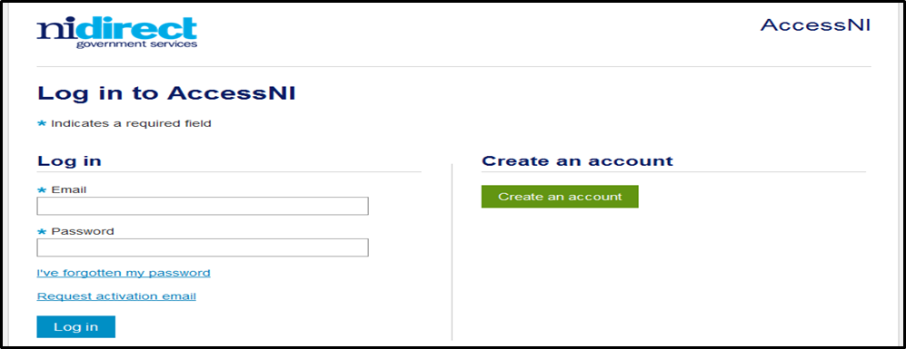

Complete the details on this form to create an account.

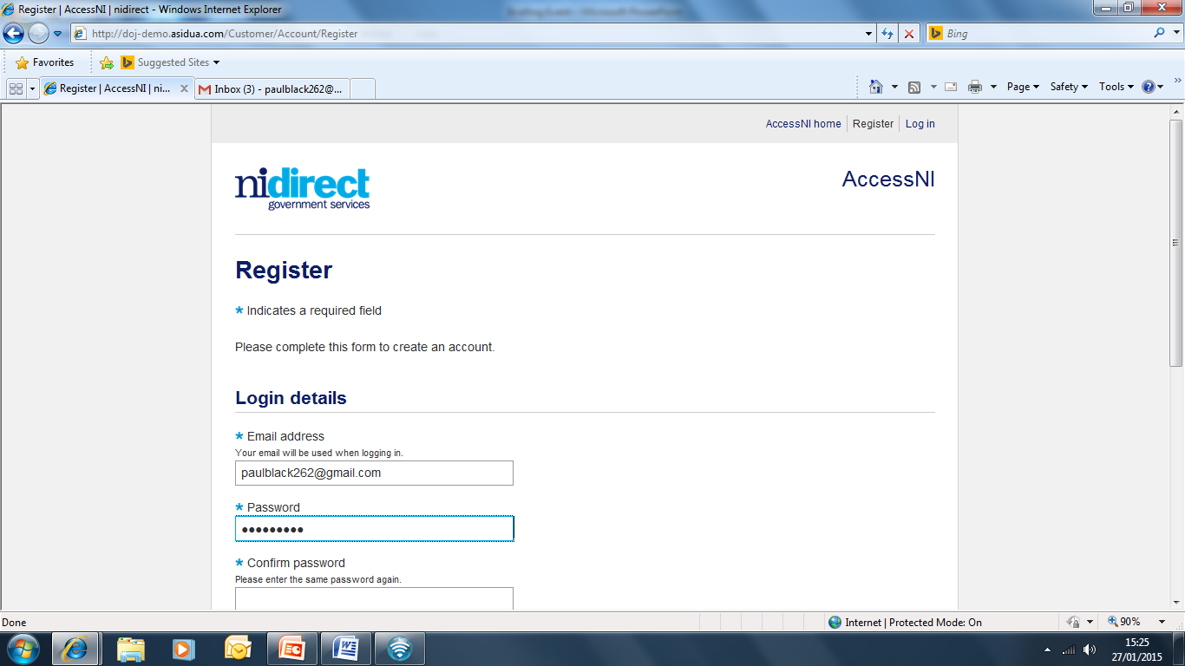

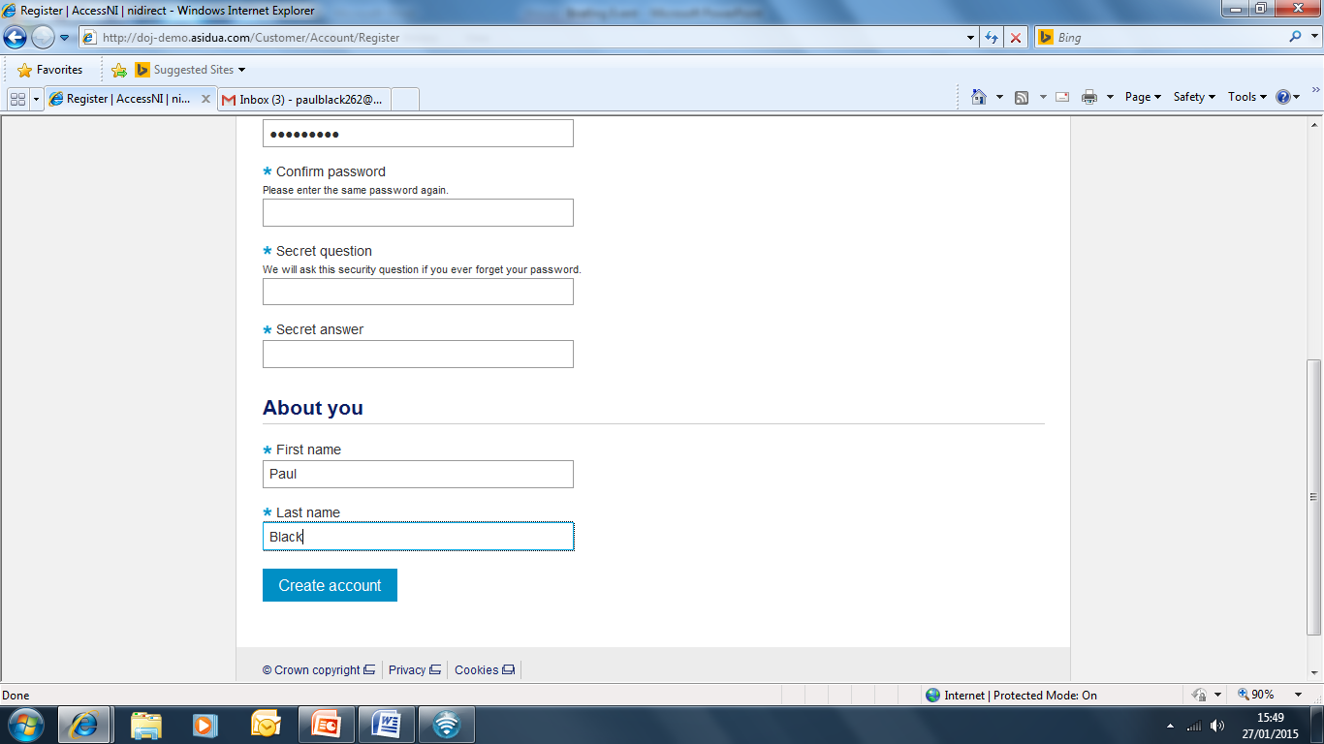

Click on Create account

Take a note of your email address and password as you will need this for completing your online application during the meeting with your Group Scout Leader.

This screen will then appear

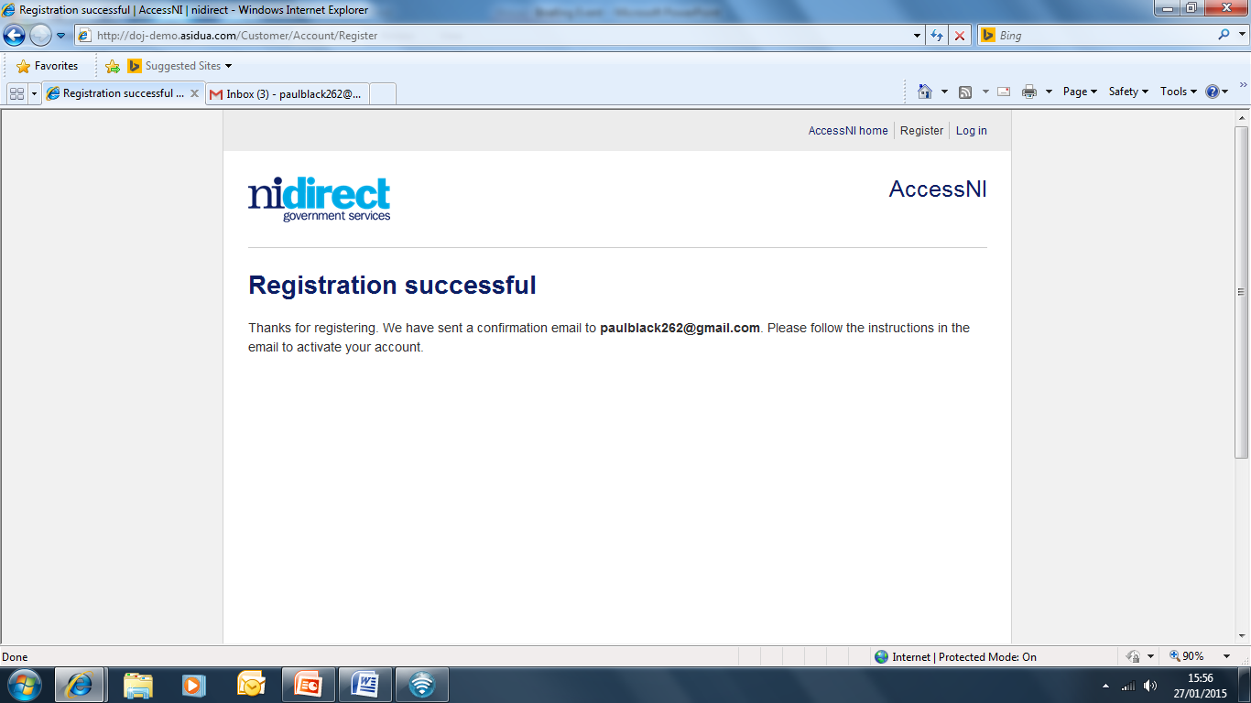

You need to log into your own email inbox where you will find a new email from AccessNI the content of which is as follows:

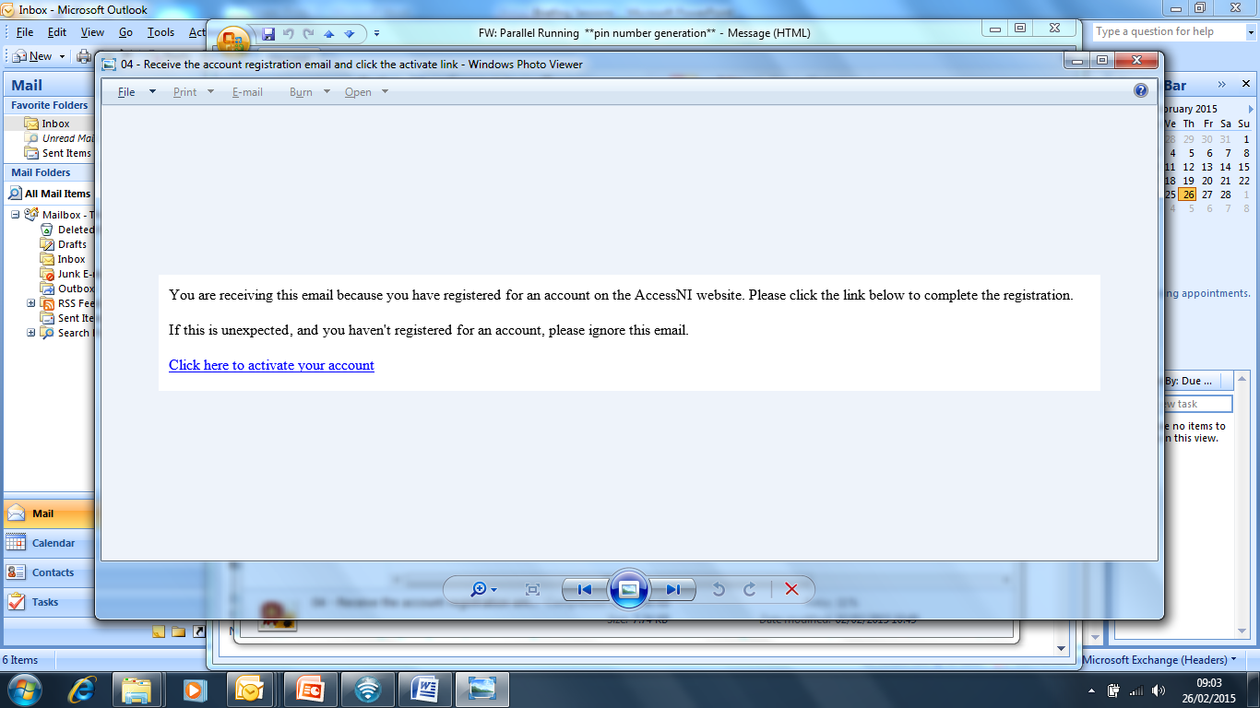

Click here to activate your account.

The remainder of your AccessNI online application will take place during the meeting with your Group Scout Leader.

When all 3 ID documents are checked, all the names from all the documents must be included in the application.

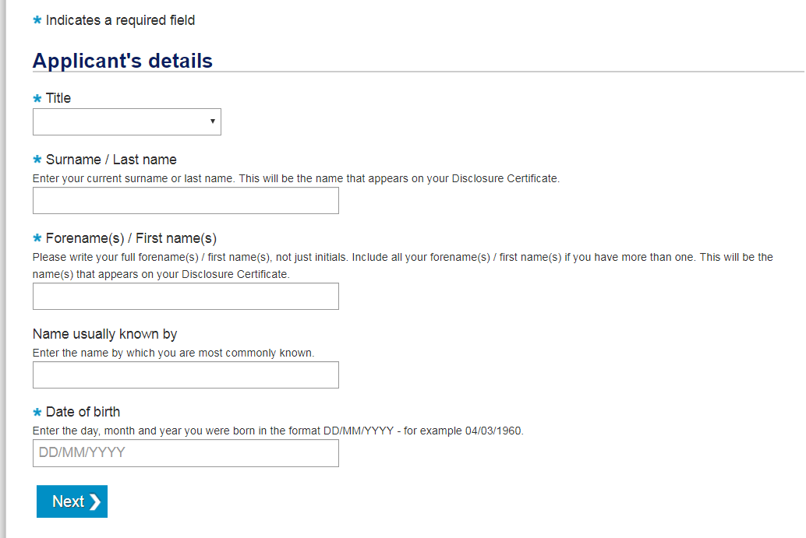

Thank you.

Name:………………………………………………………………..

Appointment: …………………………………………………..

Appendix A

The Scout Association

**Policy for Secure Storage, Handling, Use, Retention & Disposal of Disclosures & Disclosure Information (Access Northern Ireland)**

**General Principles:** As an organisation using AccessNI to help assess the suitability of applicants for positions of trust, The Scout Association complies fully with AccessNI’s Code of Practice regarding the correct handling, use, storage retention and disposal of Disclosure Applications and Disclosure information. We also comply fully with obligations under the Data Protection Act 2018 and other relevant legislative requirements with regards to the safe handling, storage, retention and disposal of Disclosure Information.

**Consent:** As we no longer receive a copy certificate from AccessNI, written consent will be obtained from the applicant when requesting and retaining a (copy of a) Disclosure certificate.

**Storage and Access:** Disclosure information is be kept securely, in lockable, non-portable, storage containers with access strictly controlled and limited to those who are entitled to see it as part of their duties.

**Handling:** In accordance with section 124 of the Police Act 1997, Disclosure information is only passed to those who are authorised to receive it in the course of their duties. We maintain a record of all those to whom Disclosures or Disclosure information has been revealed. We recognise it is a criminal offence to pass this information to anyone who is not entitled to receive it.

**Usage:** Disclosure information is only used for the specific purpose for which it was requested and for which the applicant’s full consent has been given.

**Retention:** Once a recruitment (or other relevant appointment, regulatory or licensing) decision has been taken, we do not keep Disclosure information for any longer than is necessary. We comply with AccessNI’s Code of Practice requirement to ensure that it is not retained longer than is required for the specific purpose of taking a decision on the applicant’s suitability. Disclosure certificates will be returned to the applicant once a decision, recruitment or otherwise has been made and will be retained no longer than the agreed period.

**Disposal:** Once the retention period has elapsed, we will ensure that any Disclosure information is immediately destroyed by secure means ie by shredding, pulping or burning. While awaiting destruction, Disclosure information will not be kept in any unsecured receptacle (eg waste-bin or confidential sack). We will not keep any photocopy or other image of the Disclosure or any copy or representation of the contents of a Disclosure or any other relevant non-conviction information supplied by police. However, despite the above, we may keep a record of the date of issue of a Disclosure, the name of the subject, the type of Disclosure requested, the position for which the Disclosure was requested, the AccessNI unique reference number of the Disclosure Certificate and the details of the recruitment decision.