## Access NI-Recheck Invitation

Date…………………………………………….

Dear…………………………………………….

I am contacting you to notify you that your AccessNI Disclosure Check for your role(s) in Scouting carried out

on ……………………………….…. is due to expire on ……………………………………..

Could we please arrange to meet to complete an AccessNI online application for your Recheck:

**Date:**

**Time:**

**Venue:**

To enable your AccessNI online application to be completed during our meeting, you will need to create an AccessNI NI Direct online account beforehand. See pages 3 & 4 for step-by-step instructions.

If you don’t have an email address an email account could be created in your name using a free online account such as gmail or hotmail.

Please bring the following to the meeting:

1. Your AccessNI NI Direct login details (email address and password).

2. Three documents should be produced in the name of the applicant; one from Group 1 and two from Group 1 or 2a or 2b. At least one document must show the applicant’s current address. If this is not possible, then four documents from Group 2a and 2b should be produced, one of which being a birth certificate issued after the time of birth. One document must show the applicant’s current address.

3. National Insurance number.

4. Driving licence number (if you hold one).

5. Passport number (if you hold one).

6. Your address(es) for the last five years.

**Group 1 identity documents** You must select one from the list below:

|  |
| --- |
| Current passport (any nationality) |
| Biometric Residence Permit (UK) |
| Current, valid driving licence photocard (full or provisional) (UK, Isle of Man, Channel Islands or Ireland) |
| Birth certificate issued within 12 months of birth (UK, Isle of Man or Channel Islands- including those issued by UK authorities overseas, for example embassies, High Commissions and HM Forces) |
| Long form Irish birth certificate issued at time of registration of birth (Ireland) |
| Adoption certificate (UK, Channel Islands or Ireland) |

**Group 2a identity documents** You must select two from the list below:

|  |
| --- |
| Birth certificate issued after time of birth (UK, Isle of Man, Channel Islands or Ireland) |
| Marriage/civil partnership certificate (UK, Channel Islands or Ireland) |
| HM Forces ID card (UK) |
| Firearms licence (UK, Channel Islands, Isle of Man) |
| Current, valid driving licence photocard -full or provisional (all countries outside the UK excluding Isle of Man and Channel Islands) |
| Current, valid driving licence -full or provisional -paper version if issued before 1998 (UK, Isle of Man, Channel Islands or Ireland) |
| Electoral ID card (NI only) |
| Immigration document, visa or work permit Issued by a country outside the UK. Valid only for roles whereby the applicant is living and working outside of the UK. Visa/permit must relate to the country in which the role is based. |

**Group 2b documents**

|  |  |
| --- | --- |
| Mortgage statement (UK or Ireland) | Issued within the last 12 months |
| Financial statement, for example ISA, pension or endowment (UK or Ireland) | Issued within the last 12 months |
| P45 or P60 statement (UK, Channel Islands) | Issued within the last 12 months |
| Land & Property Services rates demand (Northern Ireland only) | Issued within the last 12 months |
| Council tax statement (UK and Channel Islands) | Issued within the last 12 months |
| Credit card statement (UK or Ireland) | Issued within the last 3 months |
| Bank or building society statement (UK, Channel Islands or Ireland) | Issued within the last 3 months |
| Bank or building society statement (Countries outside the UK) – the branch must be in the country where you live and work | Issued within the last 3 months |
| Bank or building society account opening confirmation letter (UK) | Issued within the last 3 months |
| Utility bill but not a mobile telephone bill (UK or Ireland) | Issued within the last 3 months |
| Benefit statement such as Child Benefit, pensions (UK) | Issued within the last 3 months |
| Central or local government, government agency, or local council document giving entitlement, for example from the Department for Work and Pensions, The Employment Service, HMRC (UK, Channel Islands) | Issued within the last 3 months |
| EEA National ID card | Must be valid when you apply |
| 60+ or Senior (65+) SmartPass issued by Translink (NI) | Must be valid when you apply |
| yLink card issued by Translink (NI) | Must be valid when you apply |
| Cards carrying the PASS accreditation logo (UK, Isle of Man, Channel Islands) | Must still be valid when you apply |
| Letter from head teacher or further education college principal (UK - for 16 to 19 year olds in full time education - only used in exceptional circumstances if other documents cannot be provided) | Must still be valid when you apply |
| Letter of sponsorship from future employment provider or voluntary organisation (Non UK only - valid only for applicants residing outside UK and Ireland at time of application) | Must still be valid when you apply |
| Irish Passport Card (cannot be used with an Irish passport) | Must still be valid when you apply |

Thank you.

Signed: ………………………………………………………………………………………. Role…………………………………………….

Page 3

To create an NI Direct AccessNI online account, open this web address:

<https://accessni.nidirect.gov.uk/account/login>

Click on the Green Create an account button.

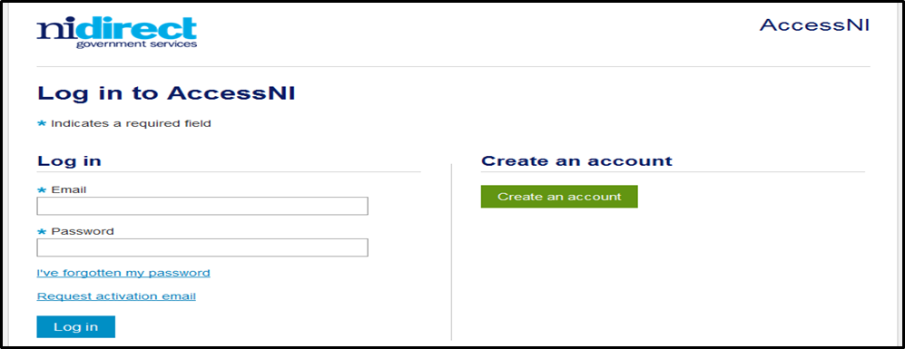

Complete the details on this form to create an account.

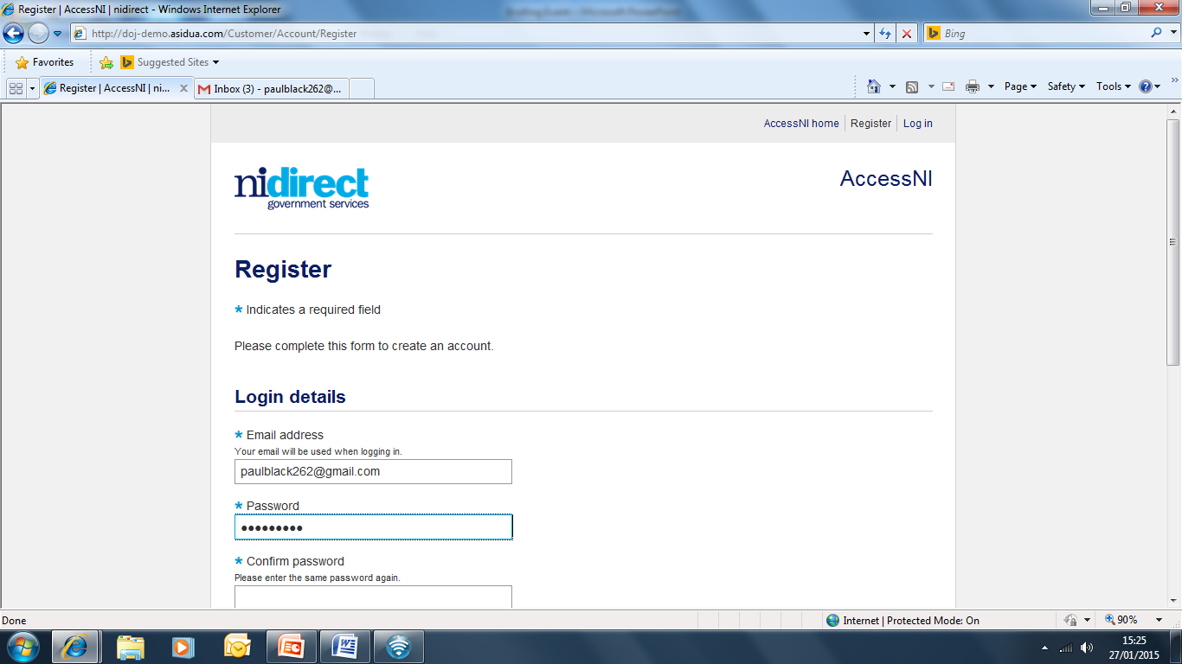

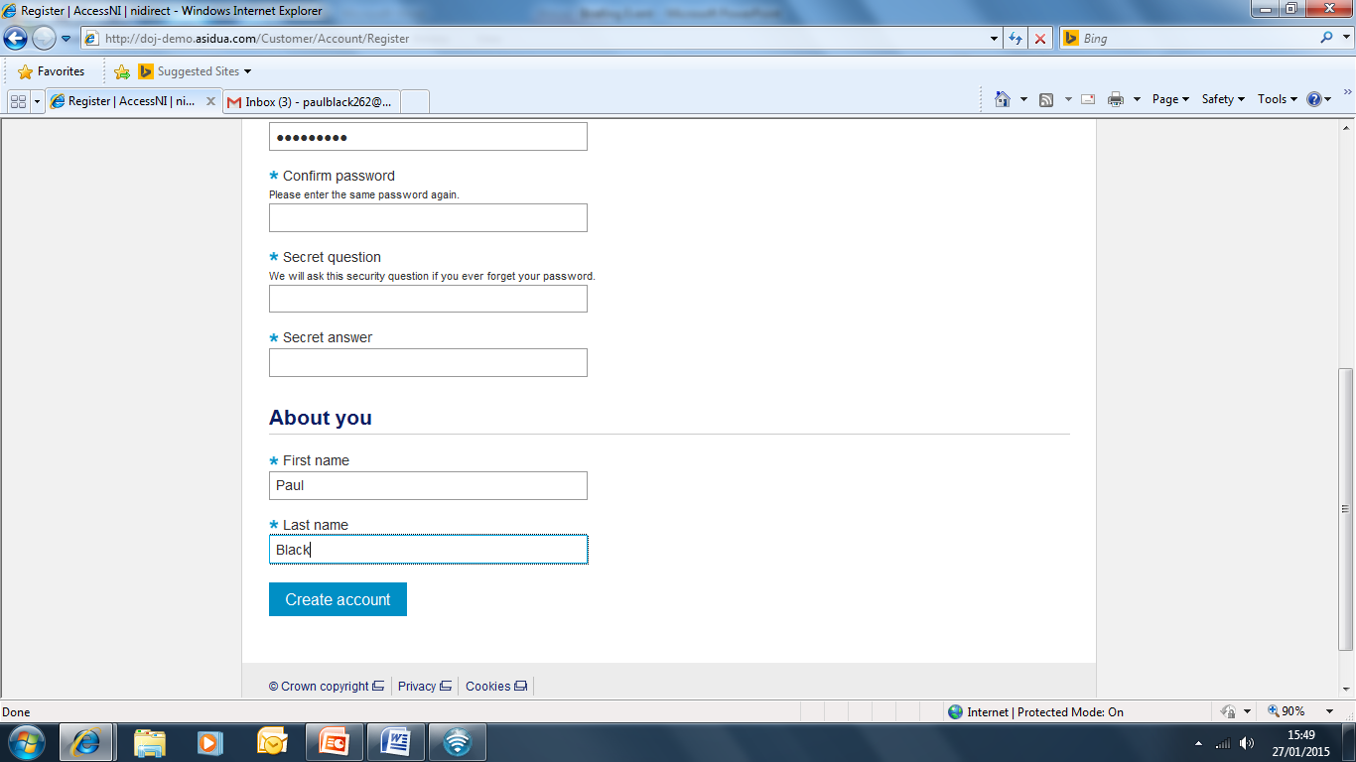

Click on Create account

Take a note of your email address and password as you will need this for completing your online application during the meeting with your ID checker.

Page 4

This screen will then appear

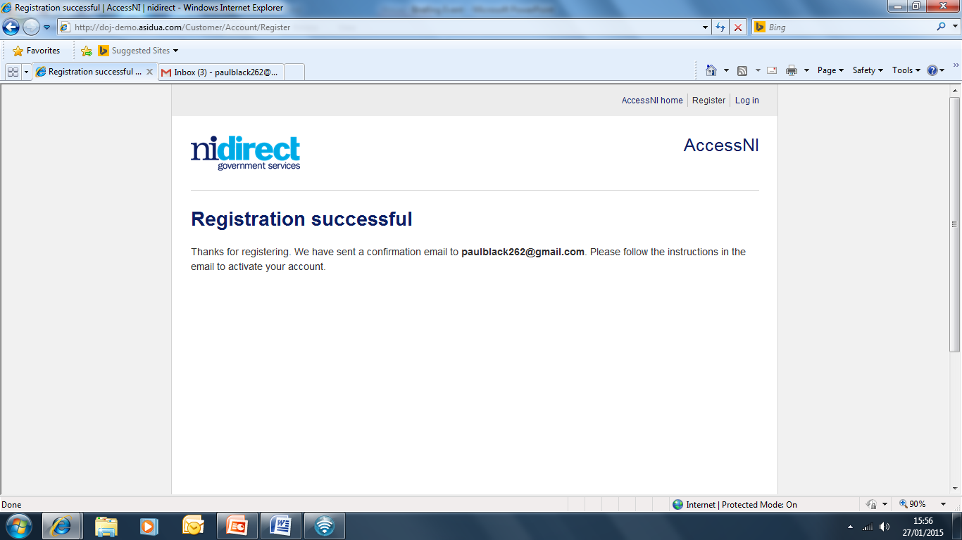

You need to log into your own email inbox where you will find a new email from AccessNI the content of which is as follows:

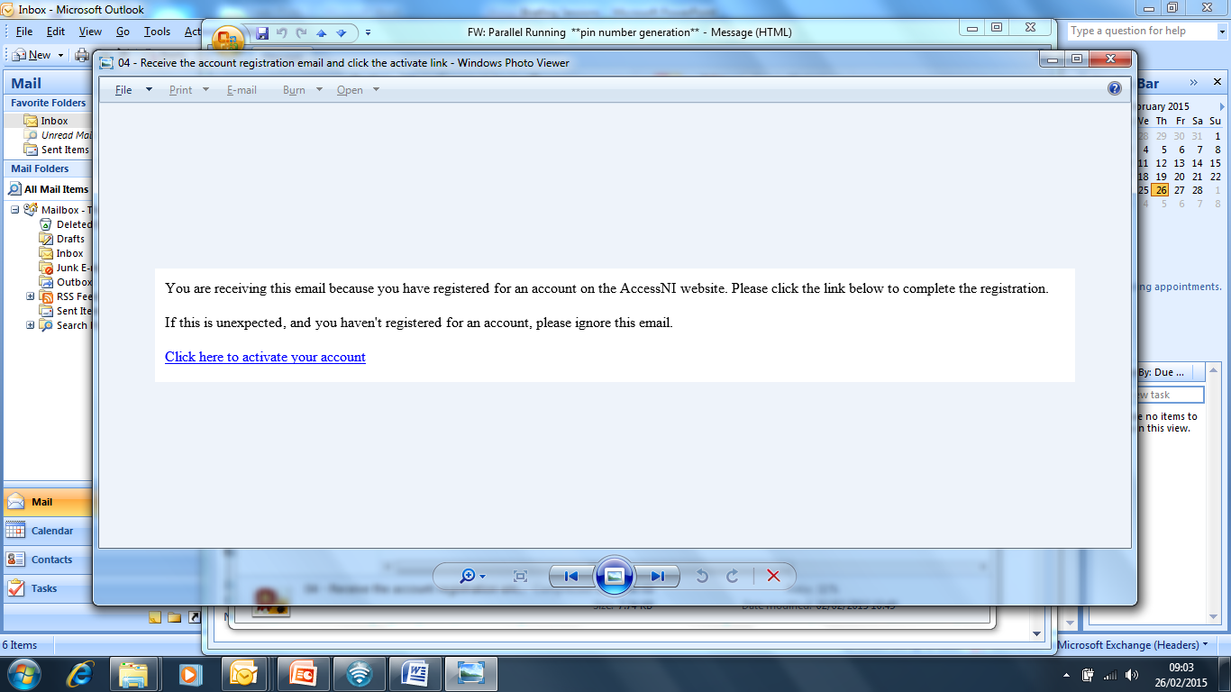

Click here to activate your account.

The remainder of your AccessNI online application will take place during the meeting with your ID Checker