## Recheck invitation letter

Date…………………………………………….

Dear…………………………………………….

I am contacting you to notify you that your AccessNI Disclosure Check for your role(s) in Scouting carried out

on ……………………………….…. is due to expire on ……………………………………..

Could we please arrange to meet to complete an AccessNI online application for your Recheck:

**Date: Time: Venue:**

The completion of the AccessNI check is an important part of keeping young people in Scouting safe, we recognise that if you have a criminal record this is not an automatic bar to obtaining a position.

Before this meeting you need to create an AccessNI NI Direct online account to enable your AccessNI online application to be completed during our meeting. See pages 3 & 4 for step by step instructions.

If you don’t have an email address an email account could be created in your name using a free online account such as gmail or hotmail.

Please bring the following to the meeting:

1. Your AccessNI NI Direct login details (email address and password).

2. Three documents in the name of the applicant; **one from Group 1 and two from Groups 1 or 2a or 2b**.

At least one document must show the applicant’s current address. If this is not possible, then **four documents from Group 2a** and **2b** should be produced. See list of suitable documents below.

3. National Insurance number.

4. Driving licence number (if you hold one).

5. Passport number (if you hold one).

6. Your address(es) for the last five years.

**Group 1 identity documents**

You must select one from the list below:

* current passport (any nationality)
* Biometric Residence Permit (UK)
* current driving licence photocard (full or provisional) (UK, Isle of Man, Channel Islands or Ireland)
* birth certificate issued within 12 months of birth (UK, Isle of Man or Channel Islands)
* original long form Irish birth certificate issued at time of registration of birth (Ireland)
* adoption certificate (UK, Channel Islands or Ireland)

**Group 2a identity documents**

You must select two from the list below:

* birth certificate (UK, ROI, Isle of Man or Channel Islands) issued after time of birth
* marriage/civil partnership certificate (UK, Channel Islands or Ireland)
* HM Forces ID card (UK)
* firearms licence (UK, Channel Islands and Isle of Man)
* current driving licence photocard (full or provisional) (all countries outside the UK excluding Isle of Man and Channel Islands)
* current driving licence, full or provisional paper version if issued before 1998 (UK, Isle of Man and Channel Islands)
* electoral ID card (NI only)
* Immigration document, visa or work permit (UK)

**Group 2b documents**

From the list below, you must use documents issued in the last 12 months:

* mortgage statement (UK or Ireland)
* financial statement, for example ISA, pension or endowment (UK or Ireland)
* P45 or P60 statement (UK, Channel Islands)
* Land & Property Services rates demand (Northern Ireland only)
* council tax statement (UK and Channel Islands)

From the list below, you must use documents issued in the last three months:

* credit card statement (UK, Channel Islands or Ireland)
* bank or building society statement (UK, Channel Islands or Ireland)
* bank or building society statement (Countries outside the UK) – the branch must be in the country where you live and work
* central or local government, government agency, or local council document giving entitlement, for example from the Department for Work and Pensions, The Employment Service, HMRC (UK, Channel Islands)
* bank or building society account opening confirmation letter (UK or Ireland)
* utility bill but not a mobile telephone bill (UK or Ireland)
* benefit statement such as child benefit, pensions (UK)

Documents on the list below must be valid when you apply for the check:

* EEA National ID card
* 60+ or Senior (65+) Smartpass issued by Translink (NI)
* yLink card issued by Translink (NI)
* cards carrying the PASS accreditation logo (UK, Isle of Man, Channel Islands)
* letter from head teacher or further education college principal (UK for 16 to 19 year olds in full time education, this is used if other documents cannot be provided)
* letter of sponsorship from future employment provider or voluntary organisation (valid only for applicants residing outside UK and Ireland at time of application
* Irish Passport Card (cannot be used with an Irish passport.

Thank you.

Name: …………………………………………………………………..

Appointment: ………………………………………………………

Access NI Code of Practice can be accessed via the Access NI website - <https://www.nidirect.gov.uk/publications/accessni-code-practice>

To create an NI Direct AccessNI online account, open this web address:

<https://accessni.nidirect.gov.uk/account/login>

Click on the Green Create an account button.

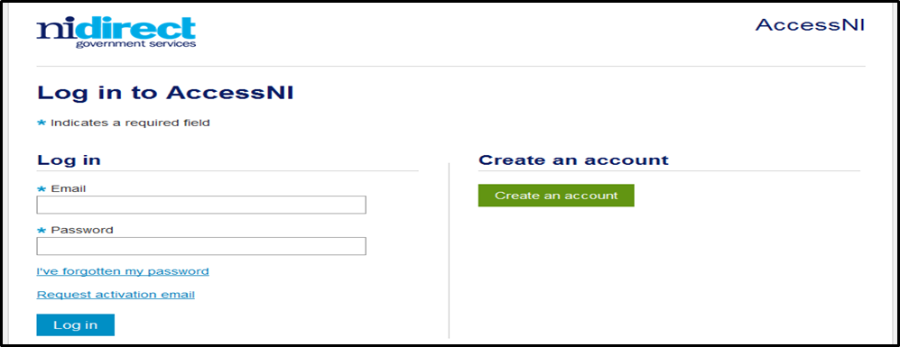

Complete the details on this form to create an account.

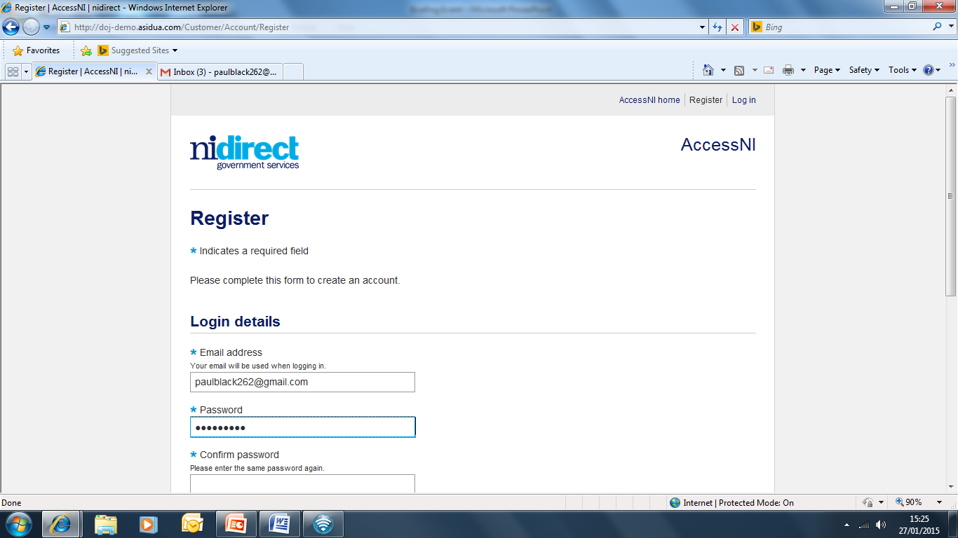

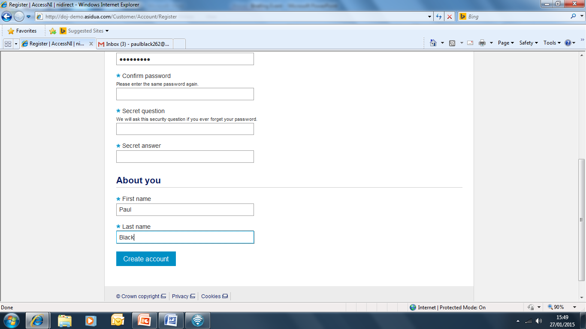

Click on Create account

Take a note of your email address and password as you will need this for completing your online application during the meeting with your Group Scout Leader.

This screen will then appear

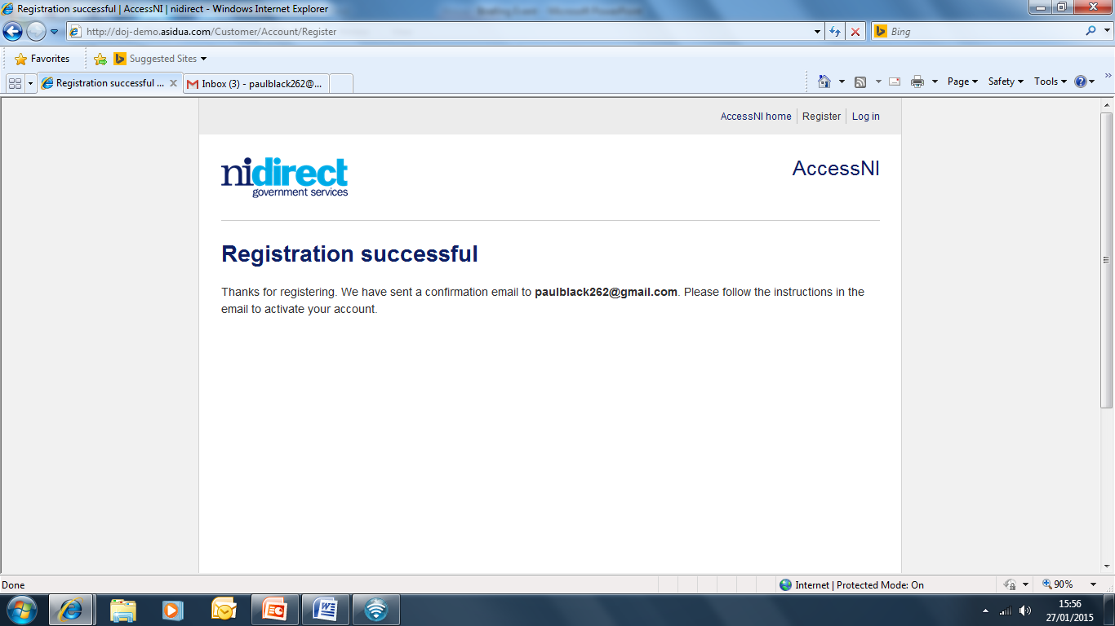

You need to log into your own email inbox where you will find a new email from AccessNI the content of which is as follows:

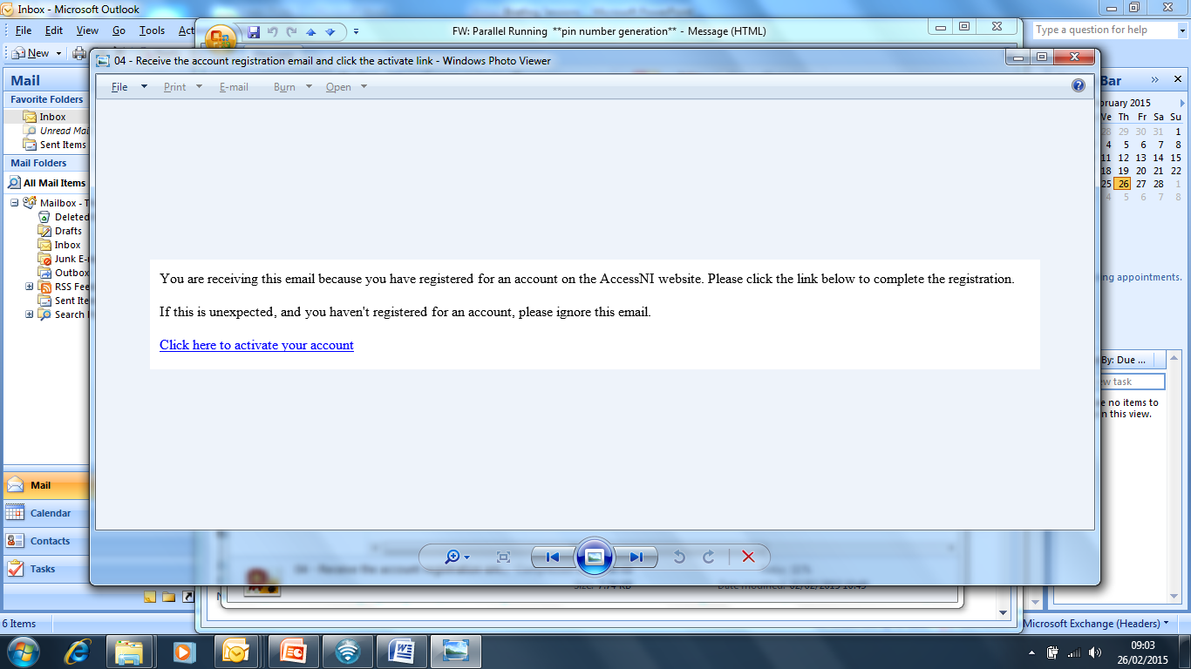

Click here to activate your account.

The remainder of your AccessNI online application will take place during the meeting with your Group Scout Leader.

When all 3 ID documents are checked, all the names from all the documents must be included in the application.

